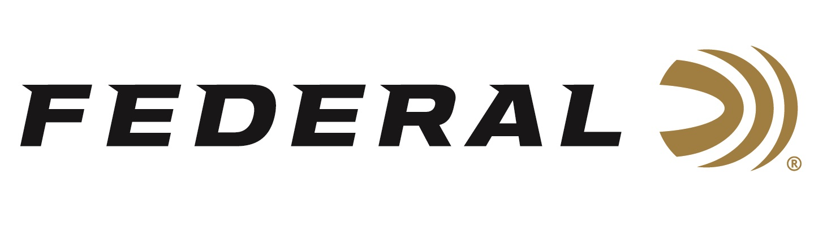

FOR IMMEDIATE RELEASE

3-Time Olympic Champ Vincent Hancock on the “It’s Federal Season” Podcast

ANOKA, Minnesota – October 21, 2021 – There is no question that Vincent Hancock loves the biggest stage when it comes to International Men’s Skeet competition. Since winning his first World Championship at the age of 16 in 2005, Hancock has been nearly unbeatable, and he proved that again at the Tokyo Olympics becoming the only male to win three Olympic gold medals in Men’s Skeet. On this episode of “It’s Federal Season” podcast, the Florida native and now Texas resident walks listeners through the competition, the low and high points, and reveals whether you’ll see him chase an unprecedented fourth Olympic title in Paris, France.

Episode #27 “3-Timer”
https://www.federalpremium.com/this-is-federal/podcast/

“Federal is a proud sponsor of the 3-time Olympic champion Vincent Hancock,” stated Jason Nash, Federal Ammunition’s Vice President of Marketing. “If you’re a fan of sports, this is a podcast for you. Not only does he talk about the significance of making history, but Hancock paints a great picture of the venue, the emotions of nearly being out after qualifications, and what it took to rise above some adversity,” stated Nash.

In the Tech Talk segment, shotshell product line manager Dan Compton reveals more information about Federal’s new High Over All competition shotshell and the features and benefits of this game changer for trap, skeet, and sporting clay enthusiasts. In the news and notes segment, Federal is excited to sponsor Thursday nights on Outdoor Channel as Federal Premium’s Terminal Ascent proudly presents the programming for hunters and shooters looking for aspirational and educational content.

For this episode, besides listening on the Federal Premium website or Talk North podcast network, you can also subscribe to Federal Ammunition’s YouTube channel (https://www.youtube.com/user/federalpremiumammo) and tune in for the discussion.

Federal Ammunition can be found at dealers nationwide or purchased online direct from Federal. For more information on all products from Federal or to shop online, visit www.federalpremium.com.

Press Release Contact: JJ Reich
Senior Manager – Press Relations
E-mail: VistaPressroom@VistaOutdoor.com

About Federal Ammunition
Federal, headquartered in Anoka, MN, is a brand of Vista Outdoor Inc., an outdoor sports and recreation company. From humble beginnings nestled among the lakes and woods of Minnesota, Federal Ammunition has evolved into one of the world's largest producers of sporting ammunition. Beginning in 1922, founding president, Charles L. Horn, paved the way for our success. Today, Federal carries on Horn's vision for quality products and service with the next generation of outdoorsmen and women. We maintain our position as experts in the science of ammunition production. Every day we manufacture products to enhance our customers' shooting experience while partnering with the conservation organizations that protect and support our outdoor heritage. We offer thousands of options in our Federal Premium and Federal® lines-it's what makes us the most complete ammunition company in the business and provides our customers with a choice no matter their pursuit.

